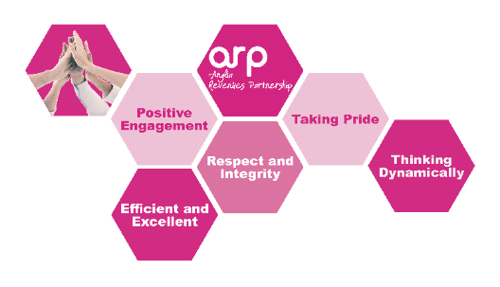
PERSON SPECIFICATION

Job Title: Compliance Officer – Enforcement
 | Essential | Desirable
Qualifications & Experience | Good general education - 2 GCSE grades,  A-C or relevant Revenues experience. | Demonstrate knowledge of Enforcement Agent regulations  Demonstrate experience of dealing with debt recovery involving vulnerable people.  Have experience of working in a busy office environment’
Knowledge | Knowledge of computer packages, including the Microsoft Suite and have the sufficient knowledge and skill to be able to use computers effectively.  Demonstrate knowledge of Debt Recovery | Working knowledge of Academy and Civica (Comino) IT systems.
Skills | Works accurately whilst understanding the importance of meeting strict deadlines.  Must be able to work to personal and team targets.  Organisational and good time management skills  Demonstrate good numerical and writing skills | Knowledge of Council Tax support and general welfare benefits
Delivering excellent Customer Service | Demonstrate experience or understanding of customer care.  Demonstrate ability to deal with customer enquiries in an appropriate, diplomatic and professional manner.  Be able to remain calm during stressful/violent circumstances. | Customer Care training
Health, Safety and Welfare | Able to demonstrate good general understanding of Health, Safety and Welfare policies and procedures  Demonstrate ability to achieve a good work life balance for self and for team
Striving for Continuous Improvement | Commitment to a learning culture  Able to give examples of flexible and positive response to change
Diversity and Equality | Ability to understand the concept of diversity and respect for others and be committed to these issues | Experience with working with vulnerable people
Communicating effectively | Good level of interpersonal and communication skills  Effectively communicates relevant information to others  Able to respond to varying levels of understanding from customers
Attitude | Must be able to self-motivate and embrace change.  Be an effective team player and can work flexibly within a team  Have a positive desire to achieve results  Can work effectively under pressure and use own initiative  Willing to learn and improve | Has a positive attitude toward work and others
Other special requirements | You may be required to drive

